**Proposal Submission**

**Request For Proposal**

**RFP-2024-105 - Coroner's Electronic Case Management System**

**Name of Proposer – Sal Venture Tech LLC**

**Address 633, West 5th Street, FL 26, Los Angeles, CA 90071**

**Telephone Number (818) 355 3270**

**Contact Person – Parag Salve**



**SECTION V - Plan Implementation**

A well-designed legal case management system is vital for the effective operation of the Coroner’s Office. This system must ensure the secure handling of sensitive case data, facilitate efficient workflows, and comply with legal standards. Below is a detailed description of the essential features and functionalities necessary for such a system.

**1. Data Management Capabilities**

**Creating, Modifying, and Securely Storing Case Data**

The system should allow users to create and modify case files with ease. Each case file must include comprehensive information, such as:

* **Case Identification**: Unique case numbers, dates, and involved parties.
* **Investigation Details**: Notes from investigations, witness statements, and evidence collected.
* **Medical Documentation**: Secure storage of autopsy reports, toxicology results, and other relevant medical evaluations.

Data security is paramount; therefore, the system must employ encryption for data at rest and in transit. Access controls should be implemented to restrict data access to authorized personnel only. Regular backups are essential to prevent data loss and ensure continuity.

In a legal case management system, the data fields can vary based on the specific needs of the firm or organization, but they shall include these and more:

Case Information:

Case ID  
Case Title  
Case Type (e.g., civil, criminal)  
Status (e.g., open, closed)  
Priority Level  
Date Opened  
Date Closed  
Parties Involved:

Plaintiff/Claimant Information  
Defendant/Respondent Information  
Witness Details  
Contact Information  
Legal Representation:

Attorney Assigned  
Co-Counsel Information  
Contact Information for Legal Team  
Documents and Evidence:

Document Type (e.g., pleadings, motions)  
Document Date  
Evidence Description  
File Attachments  
Court Information:

Court Name  
Court Location  
Judge Assigned  
Hearing Dates  
Financial Information:

Billing Information  
Fees and Costs  
Payment Status  
Retainer Details  
Notes and Communications:

Case Notes  
Communication Logs (emails, phone calls)  
Meeting Records  
Tasks and Deadlines:

Task Description  
Assigned To  
Due Date  
Completion Status  
Client Information:

Client ID  
Contact Information  
Client Preferences  
Reporting and Analytics:

Case Progress Reports  
Financial Reports  
Performance Metrics

These fields help legal professionals manage cases efficiently, ensuring that all relevant information is organized and accessible. Below flowchart shows the fields listed above. Not all fields are populated in wireframes shown below and will differ based on more field details shared by county.

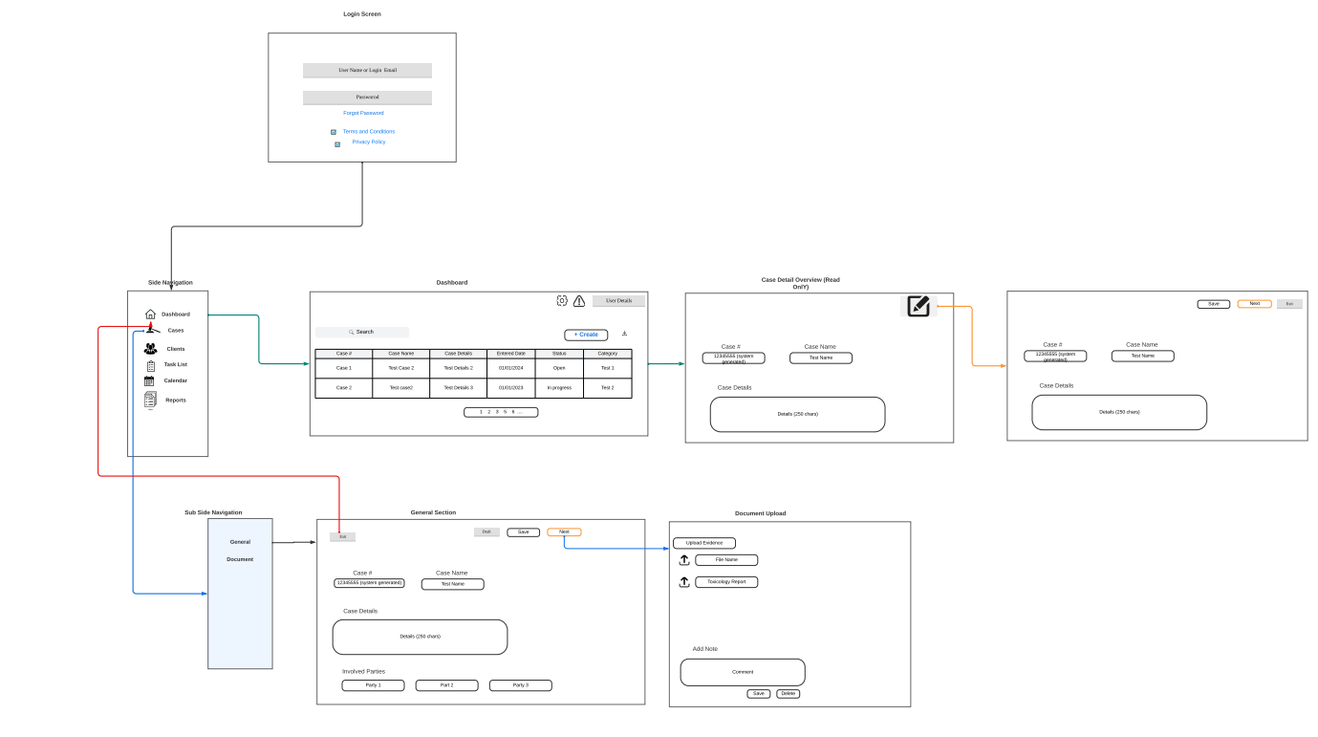*Workflow wireframe for case management system*

**2. Data Hosting and Querying**

**Hosting and Querying for Accurate Statistics**

The system must securely host large volumes of data, enabling efficient querying to generate statistics related to Coroner’s office cases. This functionality can be leveraged to:

* **Analyze Trends**: Identify patterns regarding causes of death, demographics, and case resolutions over time.
* **Generate Reports**: Create detailed reports for internal analysis or public transparency, ensuring clarity and accessibility of information.

Advanced querying tools should enable users to filter data based on various parameters, such as case type, date range, and geographic location, supporting informed decision-making.

**3. Alert System**

**User Alerts for New Information**

An alert system is essential for keeping users informed about updates to case files. Notifications should be sent when:

* **New Information is Added**: For example, when toxicology results are finalized or additional witness statements are recorded.
* **Upcoming Deadlines**: Alerts for approaching deadlines related to investigations or required reporting can enhance workflow efficiency.

Users should be able to customize their alert preferences to receive relevant updates without being overwhelmed by notifications.

**4. Customer Support**

**Technical Support During Business Hours**

To ensure smooth operation, the system must provide reliable customer support during the County’s business hours. This support shall include:

* **Help Desk Services**: A dedicated team to assist users with technical difficulties, navigation, and troubleshooting.
* **Training Programs**: Regular training sessions to familiarize staff with system features and updates, ensuring optimal use of the software.

This support structure will enhance user confidence and minimize disruptions in case management processes.

**5. Role-Based Security and Task Assignments**

**Implementing Role-Based Security**

The system should incorporate role-based security measures to protect sensitive information. Key features should include:

* **User Roles**: Different access levels for administrators, investigators, and clerical staff, ensuring that each user can access only the information pertinent to their role.
* **Task Assignments**: Ability to assign specific tasks to users based on their roles, facilitating streamlined workflows and accountability.

By defining clear roles and responsibilities, the system enhances collaboration while maintaining data integrity.

**6. Auditing Capabilities**

**Auditing System Status and Access**

An effective auditing feature is essential for monitoring system usage and ensuring compliance with legal standards. The system should allow for:

* **Access Logs**: Detailed records of who accessed what data and when, helping to identify unauthorized access attempts.
* **Usage Reports**: Insights into system utilization, identifying frequently used features and areas requiring additional training.

These auditing capabilities will help maintain accountability and transparency within the Coroner’s Office.

**7. Graphical Approval Workflows**

**Visualizing Case Processes**

The system should include graphical approval workflows that visually represent the status of each case. This feature would provide:

* **Process Visualization**: A clear depiction of where a case stands in the investigation process, including completed and pending tasks.
* **Identification of Information Gaps**: Highlight what information is still needed to move a case forward, facilitating quicker decision-making.

Such visual tools can enhance communication among team members and ensure alignment on case progress. Attached below is the work flow of overall task procedure.

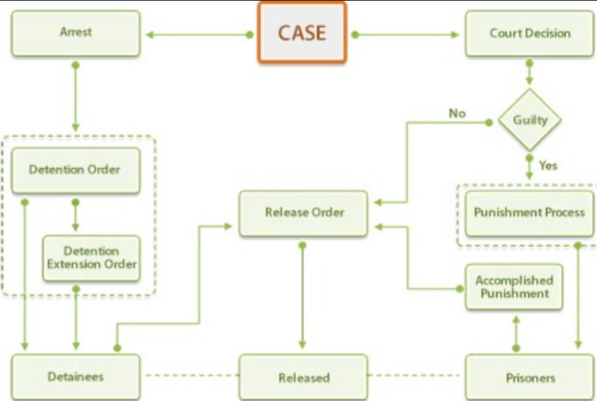  
Process Flow

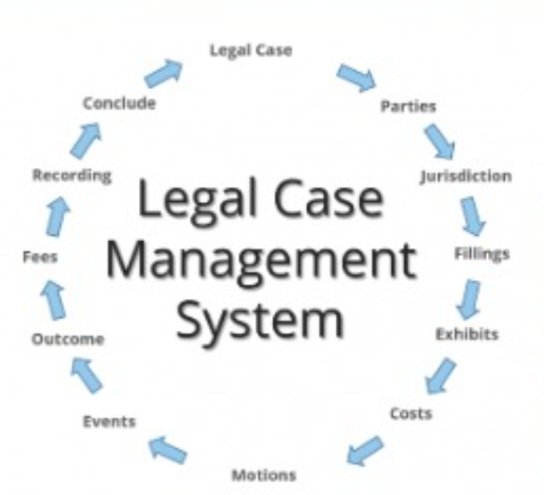

Below images show the various tabs for the case management system.

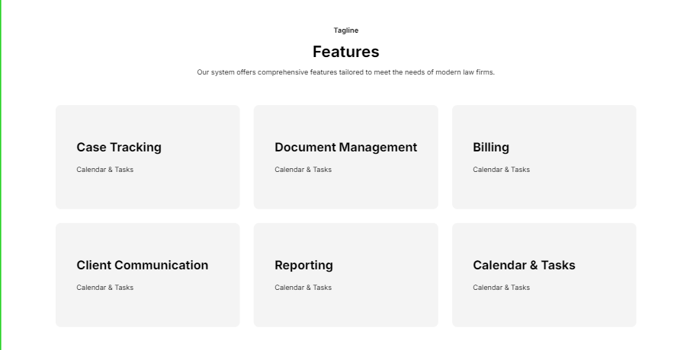

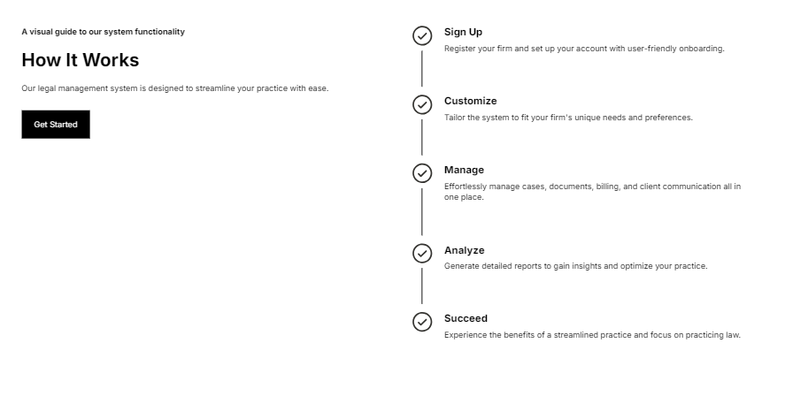

**8. Compliance with Applicable Laws**

**Adhering to Legal Standards**

Finally, the system must comply with all applicable laws related to coroner’s cases and investigations, including HIPAA regulations. Compliance features should include:

* **Data Protection**: Ensuring that all personal health information (PHI) is handled according to legal standards, with appropriate consent mechanisms in place.
* **Regular Compliance Audits**: Scheduled reviews of system practices to ensure ongoing adherence to legal requirements.

By prioritizing compliance, the Coroner’s Office can maintain public trust and uphold the integrity of its investigations.

**9**. **Storyboard for Legal Case Management System UI**

Creating a storyboard for a legal case management system UI involves visualizing the user experience through a series of screens that depict the interactions users will have with the system. Below is a conceptual outline for the storyboard, including key screens and their functionalities.

**Screen 1: Login Page**

* **Elements**:
  + Username and password fields
  + "Forgot Password?" link
  + Login button
  + Security notice (e.g., "Secure connection")
* **Functionality**: Users enter credentials to access the system securely.

**Screen 2: Dashboard**

* **Elements**:
  + Navigation menu (Home, Cases, Reports, Alerts, Settings)
  + Quick stats (e.g., number of active cases, recent alerts)
  + Calendar view for upcoming deadlines
  + Notifications panel for new updates
* **Functionality**: Provides an overview of the user's activities and quick access to important information.

**Screen 3: Case Management Overview**

* **Elements**:
  + Search bar to find specific cases
  + Filters (e.g., by status, date, type)
  + List of cases with brief details (case number, status, assigned personnel)
  + "Add New Case" button
* **Functionality**: Allows users to view and manage existing cases or create new ones.

**Screen 4: Case Detail View**

* **Elements**:
  + Case summary (case number, date, involved parties)
  + Tabs for different sections (Investigation Details, Medical Reports, Evidence)
  + "Edit" and "Delete" buttons
  + Comment section for notes
  + Attachments area for documents
* **Functionality**: Users can view detailed information about a case, make edits, and add comments or attachments.

**Screen 5: Alerts and Notifications**

* **Elements**:
  + List of alerts (e.g., new toxicology results, upcoming deadlines)
  + Filter options (e.g., by date, type of alert)
  + "Mark as Read" option
* **Functionality**: Users can manage alerts and stay informed about case updates.

**Screen 6: Reporting and Analytics**

* **Elements**:
  + Graphs and charts showing case statistics (e.g., causes of death, case resolution times)
  + Filters for customizing reports (e.g., date range, case type)
  + "Generate Report" button
* **Functionality**: Users can analyze case data and generate reports for insights and presentations.

**Screen 7: User Settings and Role Management**

* **Elements**:
  + User profile settings (name, email, password)
  + Role assignment options (e.g., admin, investigator, clerical staff)
  + Permissions management for accessing different data
* **Functionality**: Administrators can manage user roles and settings to ensure appropriate access.

**Screen 8: Audit Logs**

* **Elements**:
  + List of access logs (who accessed what and when)
  + Filters for date range and user
  + Export option for reports
* **Functionality**: Allows users to review system usage and ensure compliance with security protocols.

**Screen 9: Graphical Workflow**

* **Elements**:
  + Visual representation of the case workflow (e.g., stages of investigation)
  + Indicators for completed, pending, and required actions
  + Drag-and-drop functionality for task assignments
* **Functionality**: Users can easily track the progress of cases and identify any bottlenecks.

**10**. **Tech stack to be used based on the flowchart, storyboarding and cloud requirements**

* **MongoDB** for Database
* **React** for frontend
* **Azure** for cloud integration
* **DevExpress** to build framework.

Tech stack selection is done based on requirements shared and plan laid out though we are open to work with any other tech stack you might want to utilize.

**Conclusion**

This storyboard provides a comprehensive overview of the user interface for a legal case management system. Each screen is designed to enhance user experience, streamline workflows, and ensure secure access to sensitive information. By focusing on intuitive design and functionality, the system can significantly improve the efficiency of the Coroner’s Office in managing cases.

A comprehensive legal case management system for the Coroner’s Office must prioritize secure data handling, efficient workflows, and legal compliance. By integrating the features outlined above, the system can significantly enhance the user experience, ease of use and effectiveness of the tool.

Tech stack selection is done based on requirements shared and plan laid out though we are open to work with any other tech stack you might want to utilize.